Go to <your_site>/unicorn.aspx

Dismiss step 1 and 2 of

1. Perform Initial Serialization (if you could not see that button, go to step 3)

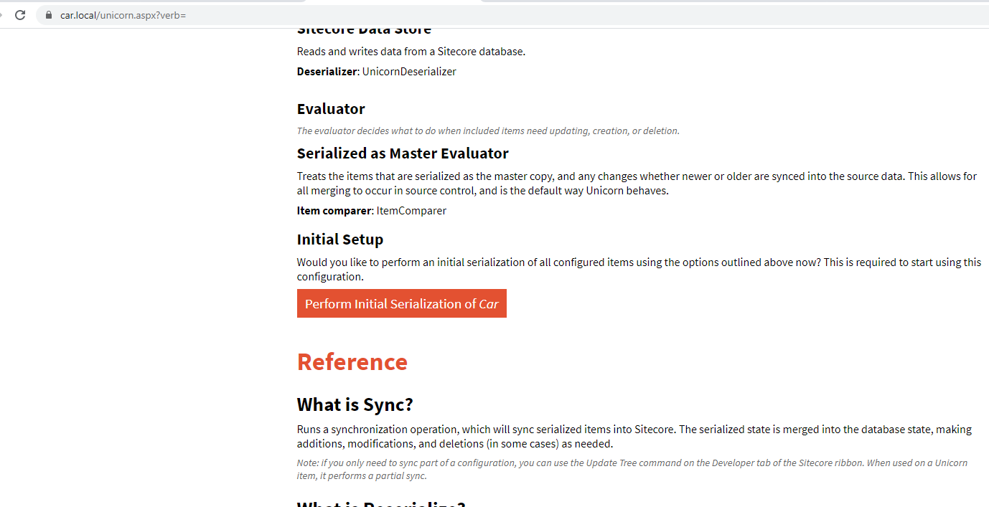

1. Your repos, solution and the webroot will look like below

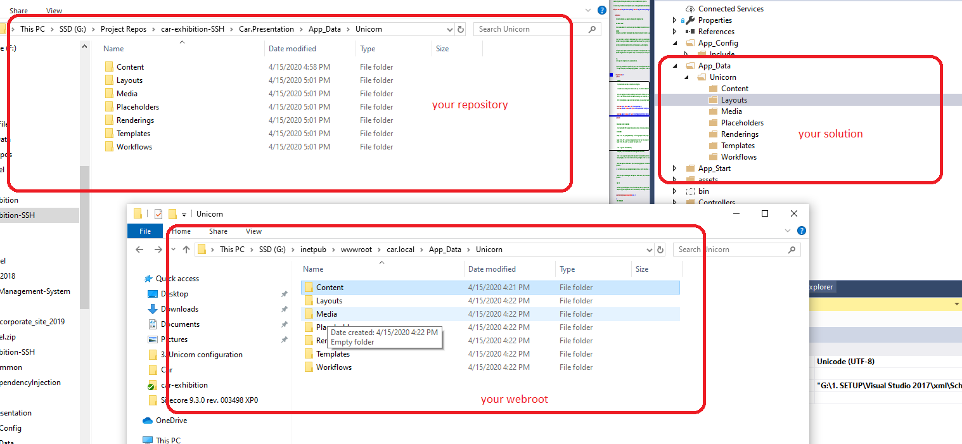

1. Install the “Sitecore Content tree base - Sitecore Package.zip” package
2. Refresh the unicorn.aspx page and Reserialize
3. You can see the files that created by Unicorn sync listed in source control:

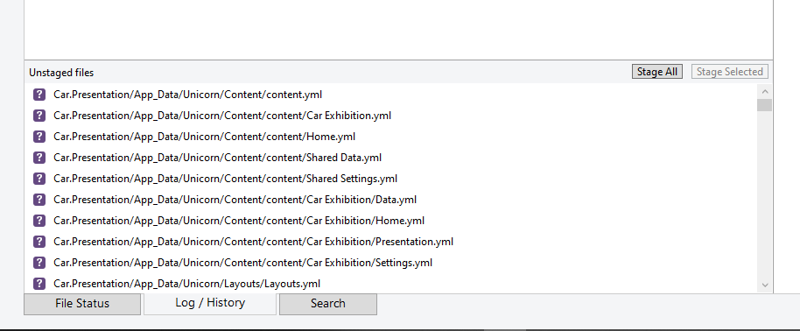

You can see any changes of your content tree in source control

1. In your solution, a lot of files with yml extension created, but Visual Studio did not include them. So I need to do it myself.

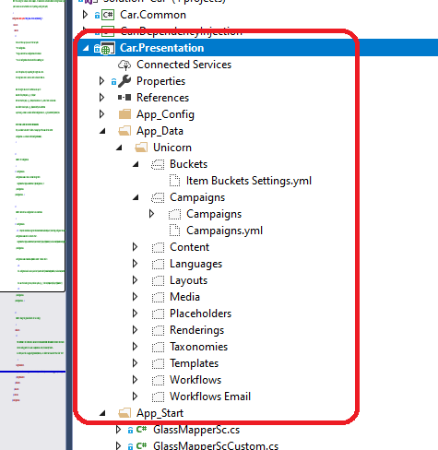

Include them:

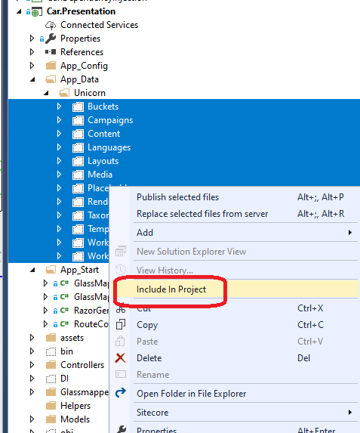

From now, if we create an item in the content tree, a file with yml extension will be created in App_Data folder too, and we need to manual include it in project.